**Sloughhouse RCD Board Meeting (12/18/24)**

**NRCS Elk Grove Updates**

**EQIP Classic**

* FY25 Application Deadline: **Ended**
* FY25 Ranking Deadline: March 14, 2025

**ACT Now fund pools that met the threshold scores are being funded on a weekly basis: IRA is currently paused**

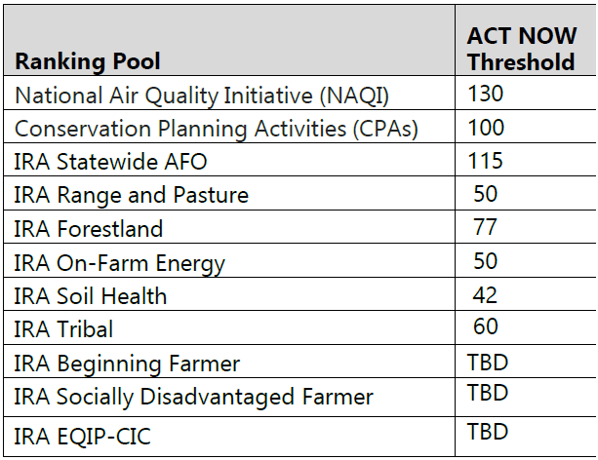

**IRA**

* On January 20, 2025, President Trump signed an Executive Order that placed a freeze on spending authorized by the Inflation Reduction Act (IRA) of 2022 and the Infrastructure Investment and Jobs Act (IIJA). This includes payments under NRCS conservation program contracts that are funded through the IRA and IIJA
* USDA leaders have been directed to assess whether grants, loans, contracts, and other disbursements align with the new administration’s policies. Now that Brooke Rollins is confirmed she will have the opportunity to review the programs and work with the White House to make determinations as quickly as possible.
* In the meantime, USDA appreciates farmers’ patience and recognizes the vital role the agricultural community plays in strengthening and sustaining our nation. We understand that uncertainty can be challenging, especially for those already navigating the unpredictable forces of nature.

**CSP Classic**

FY25 Application Deadline: April 15, 2025

FY24 Ranking Deadline: May 30, 2025

Although our application period for EQIP has ended, we accept applications year-round for all our programs and fund pools. All applications that did not meet the application cut off deadline date will compete for funding in FY2026.

**FARM BILL**

* The American Relief Act, 2025, signed into law on December 21, 2024, extended the Agriculture Improvement Act of 2018 (also known as the 2018 Farm Bill) for one year through Sept. 30, 2025.
* Currently we are working under a continuing resolution which is scheduled to expire on March 14, 2025.

**STAFFING/HIRING**:

Currently there is a hiring freeze for all government agencies. We do not have any more specific information to share at this time but will be committed to ensuring our current workforce is adequately supported.

Currently federal employees who were on their probationary period have been sent termination letters from the Human Resource Division and are no longer employed with NRCS. This has greatly impacted the field offices through California. The Elk Grove office has lost one of our employees because of this. All applications and contracts managed by this individual is being transferred to other staff.

There are employees who have also accepted the differed resignation program which is expected to reduce our workforce even further as of March 1, 2025. Our office is also affected by this.

If you have any questions about NRCS and our programs call our office at 916-582-6651. If you wish to speak with me directly you can call 916-582-6637 or email me at [Toney.Tillman@usda.gov](mailto:Toney.Tillman@usda.gov).